**INSTITUT D’ENSEIGNEMENT SUPÉRIEUR DE RUHENGERI**



###### *Scientia et Lux*

B.P. 155

Ruhengeri

Rwanda

**T** : +(250) 07 88 90 30 30

 : +(250) 08 88 90 30 32

**W** : [www.ines.ac.rw](http://www.ines.rw)

**E**  : info@ines.ac.rw

B.P. 155

Ruhengeri

Rwanda

**T**  : +(250)07 88 90 30 30

  : +(250)08 88 90 30 32

**W**  : [www.ines.ac.rw](http://www.ines.rw)

**E**  : inesruhengeri@yahoo.fr

***Accredited by Ministerial Order N° 005/2010/Mineduc of 16 June 2010***

**FACULTY OF SCIENCES AND INFORMATION TECHNOLOGY**

**DEPARTMENT OF COMPUTER SCIENCES**

**OPTION OF INDUSTRIAL INFORMATION TECHNOLOGY**

**REAL-TIME LOCATION IDENTIFICATION –BASED BUS TRACKING AND AUDIO ALERTS FOR PASSENGERS**

**CASE STUDY: MUSANZE-KIGALI ROAD**

A dissertation Submitted in partial fulfilment of requirements for the

award of a Bachelor’s Degree of Science in Computer Science,

Option of Industrial Information Technology.

**By: BYIRINGIRO Providence**

**Reg_number: 23/21373**

**Supervisor: NTEZIRIZAZA NKERABAHIZI Josbert**

**Musanze, 2025**

# DECLARATION

I do hereby declare the work presented in this dissertation is an original work resulting from any determination and hard work, it has never been submitted to any University or Institution. I, therefore declare this work is my own for the partial fulfillment of the award of Bachelor’s degree of Science in computer science, with honors in Industrial Information Technology at INES-Ruhengeri.

Candidate's name: BYIRINGIRO Providence

Candidate’s Signature: …………………………….

Date of Submission: ………………………………………

# 

# APPROVAL

This is to certify that this dissertation work entitles”Real-time location identification-based bus tracking and audio alert for passengers” is an original study conducted by BYIRINGIRO Providence under my supervisor and guidance.

Supervisor’s name: Dr. NTEZIRIZAZA NKERABAHIZI Josbert

Signature of the Supervisor: ………………………………….

Date of Submission: ………………………………………...

# 

# DEDICATIONS

**This is dedicated to:**

Almighty God

My husband and children

My parents and siblings

FAWE RWANDA

My supervisor

My lectures

My collegues

My colleuges

# ACKNOWLEGMENTS

First and foremost, I want to thank almighty God for His protection from the first day at Ines-Ruhengeri until now, for His blessings, and for everything He has done for me. I want to express my gratitude to all the people who have been pivotal in bringing this dissertation to fruition. Their support, guidance, and assistance have been crucial in shaping this work. I am truly thankful to the following individuals:

I owe a great debt to my Supervisor, Dr. NTEZIRIZAZA NKERABAHIZI Josbert. His guidance, advice, and insights have been instrumental in developing this dissertation. His expertise and encouragement have significantly influenced the outcome of this work.

To the teachers and staff in the Department of Computer Sciences at the Faculty of Applied Fundamental Sciences, thank you for fostering an environment where learning and research can thrive. The knowledge I’ve gained here has been fundamental in shaping the content of this dissertation.

I extend my heartfelt thanks to my husband, parents, FAWE Rwanda and my family. Their love, support, and sacrifices have been the cornerstone of my education. Their unwavering belief in me to strive for excellence. This work is dedicated to them with deep gratitude.

I also want to acknowledge my classmates and friends. Their inspiration and motivation have been in valuable throughout my studies. Their diverse perspectives and teamwork have enriched my learning experience.

Lastly, a sincere thank you to everyone who has directly or indirectly contributed to the completion of this dissertation. Even the smallest contributions have been part of this journey. Your efforts have greatly influenced my academic and personal growth. This dissertation is the result of our collective efforts. Thank you from the bottom of my heart.

# Abstract

Many passengers who use public buses often don’t know exactly where the bus stop is or when it will reach their stop especially in places where modern GPS systems are too expensive or hard to use. This study focuses on solving that problem on the Musanze–Kigali road by building a simple, low-cost system that does not need GPS or internet. The proposed system uses two small devices called ESP32 microcontrollers. One device is placed at each bus stop and works as a Bluetooth transmitter. The other device is installed on the bus and works as a Bluetooth receiver. When the bus gets close to a stop, the receiver picks up the Bluetooth signal from that stop. This tells the system that a bus stop is near. Then, a small speaker on the bus automatically plays a pre-recorded voice message, telling passengers the name of the upcoming stop. It is especially helpful for people who are visually impaired, elderly, or new to the area. Instead of relying on apps, maps, or data connections, passengers are informed using clear audio alerts. This removes uncertainty and makes the travel experience more relaxed and confident for everyone on board. Additional, The system was tested using real bus routes and received positive feedback from passengers. People reported feeling more aware of where they were along the route, and they appreciated the announcements, especially in rural or less-developed areas. To this end, this study proves that Bluetooth-based tracking can improve public transportation in Rwanda without needing expensive technology, and it can be extended to other roads and transport systems across the country… the results from the testbed/simulation illustrated….. ……

## CHAPTER ONE: GENERAL INTRODUCTION

# 1.1 Introduction

This chapter is made of background of the study, problem statement, general objectives and specific objectives, research questions, research hypothesis, significance of the study, delimitation of the study and research methodology.

# 1.2 Background of the Study

Public transportation is a critical part of urban infrastructure, with buses being one of the most commonly used modes of transport. However, a significant challenge faced by passengers is the uncertainty of bus arrival times and the difficulty of knowing when to get off at the right stop. While GPS-based systems are commonly used for real-time bus tracking, they are often costly and complex to implement in many areas. There is a need for more affordable, efficient solutions that provide accurate location-based information for passengers. Reference

This study proposes an innovative bus tracking system using Bluetooth technology with two ESP32 microcontrollers: one acting as a Bluetooth transmitter and the other as a receiver. When the receiver gets near the transmitter, it will know that the bus is at a specific stop. The system will provide audio alerts for passengers via an RDFplayer Mini that plays recorded messages through a speaker, notifying passengers when their stop is approaching. Reference

The system is particularly valuable for passengers who are visually impaired or unfamiliar with the travel road especially in areas where access to live road information is limited. By playing automatic audio notifications when the bus is close to a designated stop, passengers are informed in real time without needing to constantly ask the driver or fellow passengers. This enhances independence and confidence, making public transportation more user-friendly. Reference

Moreover, the use of Bluetooth overcomes the need for expensive GPS hardware and data subscriptions, making this solution ideal for low-resource environments like some rural areas of Rwanda. The Musanze-Kigali road, which passes through both urban and rural zones, serves as the case study for this research. By focusing on this road, the project aims to demonstrate that Bluetooth-based solutions can bridge the digital gap in public transport, ensuring that all categories of passengers benefit equally from technological improvements (Bai et al., 2020).

# 1.3 Problem Statement

In Rwanda, especially along the Musanze-Kigali public road, many passengers face daily challenges when using buses due to the lack of real-time information about current bus stop. Passengers confused on the name of bus stop, which leads to wasted time and frustration when they overbroad. Passengers in the bus especially those who are new to the route or traveling to unfamiliar areas struggle to know when to get off at the correct stop. This is even more difficult for people with visual impairments who cannot read signboards.

Currently, some advanced transport systems around the world solve this problem using GPS technology. These systems allow buses to be tracked in real-time and notify passengers when a stop is approaching. However, GPS systems are costly, require internet data and satellite signals, and need complex setups and maintenance. Most local transport services in Rwanda, particularly on mixed urban and rural roads like Musanze-Kigali, cannot afford such expensive technologies.

As a result, there is a clear need for a simpler, low-cost, and reliable solution that can help both the bus operators and passengers regardless of location. This research aims to address this problem by developing a Bluetooth-based bus tracking system that works without internet or GPS. The system will use ESP32 microcontrollers one placed at each bus stop and another on the bus. When the bus approaches a stop, the receiver will detect a signal from the transmitter and trigger an audio alert using an RDFplayer Mini to inform passengers about the nearby stop.

This approach not only makes public transportation more accessible for visually impaired passengers but also improves the overall user experience for everyone, along the Kigali–Musanze road. It is a practical solution designed to bring smart transport benefits to places that have been left behind by expensive, GPS-based systems.

# 1.4 Objectives

To achieve the aim of this study, the general and specific objectives can be formulated as follow:

# 1.4.1 General Objectives

The main objective of this study is to design and implement a Bluetooth-based bus tracking system with audio alerts for passengers using two ESP32 devices.

# 1.4.2 Specific Objectives

* To design a Bluetooth-based location detection system that can identify the bus stop using proximity sensing.
* To integrate an RDFplayer Mini for playing recorded audio alerts to notify passengers when they are near their destination.
* To develop a simple and user-friendly interface for passengers to interact with the system.
* To evaluate the effectiveness of the system in providing timely alerts and improving passenger experience.
* To ensure that the system operates reliably across both urban and rural environments parts of Musanze-Kigali road.

# 1.5 Research Questions

This study will attempt to answer the following research questions:

* How accurately can the proximity of the Bluetooth transmitter and receiver identify a bus stop?
* Does the integration of audio alerts improve the experience of passengers, especially those with visual impairments and unfamiliar of road?
* How effective is the system in reducing passenger anxiety regarding bus stop identification?
* What are the technical challenges in using Bluetooth technology for real-time bus stop identification?
* Can this Bluetooth-based system operate effectively in various environmental conditions found along mixed urban and rural roads like Musanze-Kigali?

# 1.6 Significance of the Study

This study is important because it introduces a low-cost bus tracking system using Bluetooth instead of GPS. On Musanze-Kigali road, many buses lack real-time tracking, making it hard for passengers especially those with visual impairments or tourists to know where they are or when to get off. By using ESP32 microcontrollers and audio alerts, this system helps passengers get notified when they are near their stop. It improves comfort, reduces confusion, and makes public transport more inclusive. Since it works without the internet or GPS, it’s ideal for both urban and rural areas along the bus line.

# 1.7 Study Delimitation

This study is about creating a Bluetooth-based bus tracking system for the Kigali–Musanze public road, which connects Musanze District in the Northern Province of Rwanda to Nyarugenge District in Kigali City. The proposed system uses two ESP32 microcontrollers one on the bus and one at each bus stop to sense when the bus is nearby. When the bus gets close to a stop, the system plays a recorded audio message using an RDFplayer Mini to let passengers know the stop which is near. The system can only detect nearby bus stops and does not show the bus's exact location on a map. Even though this project is made for the Musanze-Kigali road, it can be improved and used on other roads in the future. It is a low-cost and useful solution for both cities and countryside areas.

# 1.8 Research Hypothesis

The following hypothesis will be tested in this study:

* H1: The Bluetooth-based bus tracking system using ESP32 devices will significantly reduce the uncertainty passengers face regarding bus stop locations.
* H2: The integration of audio alerts will improve the accessibility and overall satisfaction of passengers, especially those with visual impairments.
* H3: The system will be easy to use and understand by passengers of different backgrounds, including those unfamiliar with the Musanze- Kigali road.
* H4: The use of Bluetooth instead of GPS will lower implementation costs while still offering reliable performance for detecting bus stop proximity.

# 1.8.1 Choice of the Study

This study was chosen to solve the problem of passengers missing their stops on the Musanze- Kigali road, especially those with visual impairments or new to the area. GPS systems are costly, so a Bluetooth-based solution using ESP32 was selected as a simple, affordable option. The road connects both city and rural areas, making it a good case for testing the system's usefulness.

# 1.8.2 Research Methodology

The research will use a practical design and qualitative approach. Two ESP32 devices will be used: one as a Bluetooth transmitter at bus stops and the other as a receiver on the bus. The RDFplayer Mini will play audio alerts when the bus nears a stop. Data will be collected through interviews, observations, and surveys to evaluate the system's effectiveness. (Trivedi, 2021).

# 1.8.3 Qualitative Methods

Qualitative research was used to understand the challenges passengers face on the Musanze- Kigali road, especially with identifying bus stops. Feedback was gathered through interviews and questionnaires from passengers, drivers, and transport operators (Simister & James, 2020).

# 1.8.4 Semi-Structured Questionnaires

Semi-structured questionnaires helped gather views from passengers and transport workers about their challenges and suggestions. This method allowed open feedback while guiding the conversation to understand how the new Bluetooth-based system could improve their journey.

# 1.8.5 Agile Methodology

Agile is a flexible way to manage projects by working in small, manageable steps. In this study, the Agile method was used to build the system gradually—starting with Bluetooth detection, then audio alerts, and finally installing the components. Each part was tested and improved based on feedback, making the process faster and more adaptable to any changes or issues. (Trivedi, 2021).

# 1.9 Expected Results

The expected result is a working Bluetooth-based bus tracking system that detects nearby bus stops using ESP32 devices. Passengers, especially those with visual impairments, will get timely audio alerts, making it easier to know when to get off. The system should prove to be a low-cost and helpful alternative to GPS, especially for Musanze-Kigali road.

# 1.10 Organization of the Study

This dissertation is organized into five main chapters:

* **Chapter 1: General Introduction** – Provides the background of the study, states the problem, objectives, research questions, hypothesis, and significance of the study.
* **Chapter 2: Literature Review** – Discusses theoretical concepts, related work, and identifies the gaps this study aims to fill.
* **Chapter 3: Research Methodology** – Describes the methods used to collect data, explains how the system was designed and developed, and how testing was done.
* **Chapter 4: Design and Implementation** – Covers the technical details of how the Bluetooth-based system was built and how it works in real-life settings.
* **Chapter 5: Conclusion and Recommendations** – Summarizes the main findings and suggests possible improvements or future work.

## CHAPTER TWO: LITERATURE REVIEW

# 2.1 Introduction

This chapter reviews key concepts and past studies related to smart bus tracking systems. It defines important terms like Bluetooth communication and ESP32 microcontrollers, and looks at existing technologies that help passengers identify bus stops. The review highlights gaps in current systems, such as high cost and lack of support for visually impaired users, and explains why a simple, affordable Bluetooth-based solution is needed especially for road Musanze-Kigali. (Axelsson et al., 2022).

# 2.2 Key Concept Definitions

The development of a bus tracking system that uses real-time location identification and audio alerts involves several essential concepts:

# 2.2.1. IoT Technology

The Internet of Things (IoT) refers to the network of interconnected devices that communicate over the internet without human intervention. In the case of the bus tracking system, IoT allows various devices like the ESP32, Bluetooth modules, and RDFplayer to communicate with each other and share data. The key benefit is the seamless, automated operation of the system, enabling real-time location updates and audio notifications for passengers (Jordi Salaza & Silvestre, 2017).

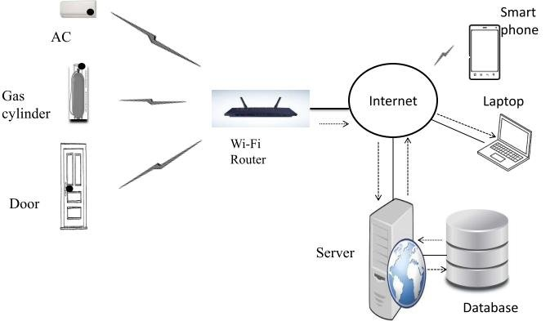

**Figure 1: IoT Technology** (Jordi Salaza & Silvestre, 2017)

# 2.2.2. ESP32 Microcontroller

The ESP32 is a highly versatile and powerful microcontroller, ideal for IoT-based applications. It supports both Wi-Fi and Bluetooth, which are essential for implementing the real-time location tracking and audio alert systems in the bus tracking project. It features dual-core processing, sufficient GPIO pins for interfacing with sensors and other components, and low-power operation, making it perfect for long-duration applications like bus tracking. The ability of the ESP32 to handle multiple tasks in real-time is crucial for ensuring accurate tracking and timely audio alerts (Espressif Systems, 2021).

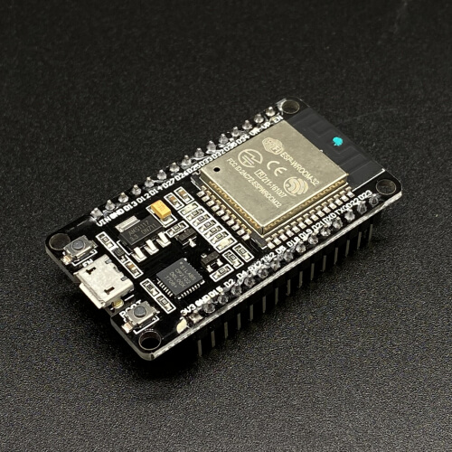

**Figure 2: ESP32** (Espressif Systems, 2021)

# 2.2.3. Bluetooth Technology

Bluetooth technology is used to establish communication between devices over short distances. In the bus tracking system, Bluetooth is utilized to detect the proximity of passengers to a specific bus. The Bluetooth transmitter on the bus continuously broadcasts its signal, and the receiver, which could be carried by the passengers or placed in the bus stop area, identifies the signal strength. Based on the strength, an audio alert is triggered, informing passengers the name of bus stop arrival. Bluetooth Low Energy (BLE) is often preferred due to its power efficiency (Mohamed, 2022).

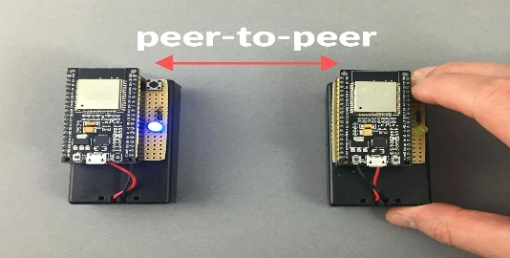

**Figure 3: Bluetooth Technology** (Mohamed, 2022)

# 2.2.4. RDFplayer Mini and Audio Alerts

The RDFplayer Mini is an audio playback module that can store and play back audio files from a memory card. In the bus tracking system, the RDFplayer Mini can store pre-recorded audio alerts that notify passengers when the bus is near a specific stop. The integration of this module with the ESP32 allows for efficient and low-cost audio notification. The system can trigger specific audio files based on proximity, ensuring passengers are notified in real time (PICAKE, 2020).

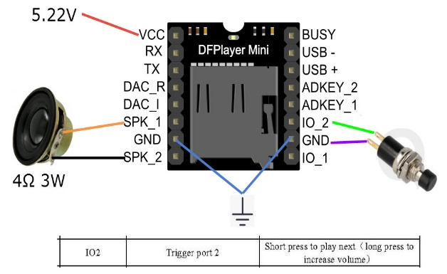

**Figure 4: RDFplayer Mini** (PICAKE, 2020)

# 2.2.5. Motor Driver (L298N) and 4WD Robot Smart Car Chassis

The L298N motor driver is used to control motors in the robot chassis, which can represent the bus itself in a simplified model for testing. The 4WD Robot Smart Car Chassis Kit COM37 enables us to build a mobile robot with four motors, ideal for simulating the movement of a bus (Controlled et al., n.d.).

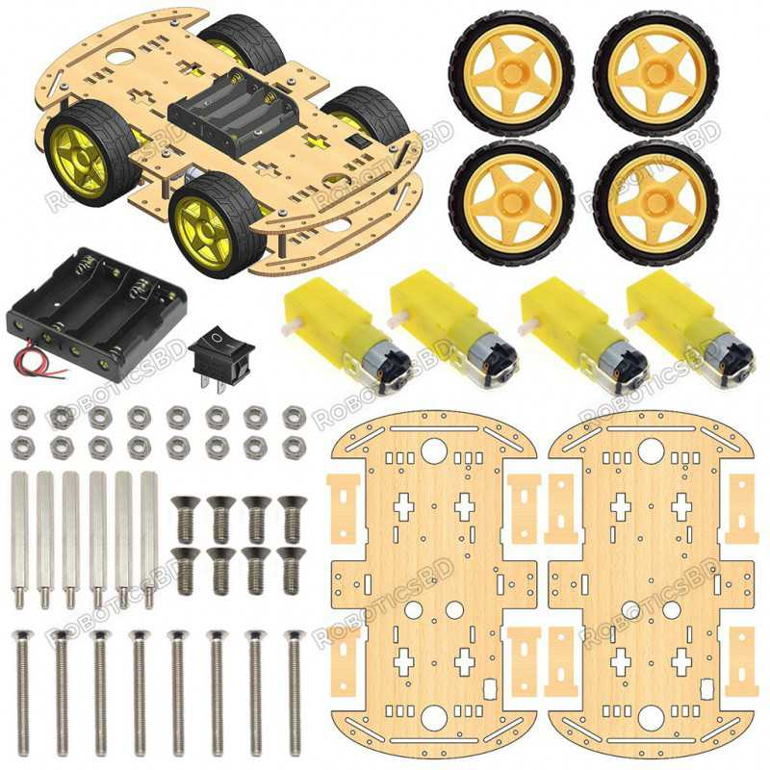

**Figure 5: 4WD Robot Smart Car Chassis** (Controlled et al., n.d.)

The L298N motor driver and chassis kit can be used to build a mobile test platform for the bus tracking system, allowing easy testing and control of motor direction and speed before full deployment. (Handson Technology, 2021b).

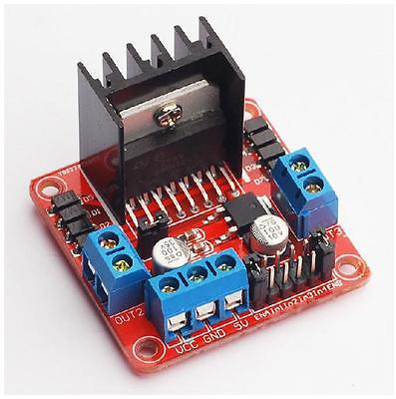

**Figure 6: L298N** (Handson Technology, 2021b)

# 2.2.6. Location Tracking Using Bluetooth

This system uses **two ESP32s** and **Bluetooth** to detect when a bus reaches a stop. One ESP32 is installed on the **bus** and constantly sends out a Bluetooth signal. Another ESP32 is placed at the **bus stop** and waits to detect that signal. When the bus comes close, the signal becomes strong. The ESP32 at the bus stop senses this and plays a **pre-recorded audio alert** using a DFPlayer Mini to inform passengers that the bus has arrived (Bai et al., 2020).

# 2.2.7. LCD 16x2 Display with I2C

The LCD 16x2 (I2C) is used to display the current status of the bus or system to the operator or passengers. It can show information like the bus's current location, status messages, or notifications. The use of I2C ensures efficient communication between the LCD and the ESP32, while minimizing the number of GPIO pins required for operation. This display is essential for providing a clear, user-friendly interface for the system (Handson Technology, 2021a).

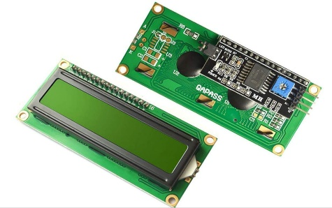

**Figure 7: LCD I2C 16x2** (Handson Technology, 2021a)

# 2.2.8 Jumper Wires and Breadboard

Jumper wires and breadboards are essential for prototyping and testing the circuit before finalizing the design. Jumper wires are used to connect various components, such as the ESP32, sensors, and actuators, without the need for soldering. A breadboard allows for the temporary setup of the system, enabling easy adjustments and testing. This flexibility is crucial in the development phase, especially when working with complex systems like IoT applications (Ada, 2018).

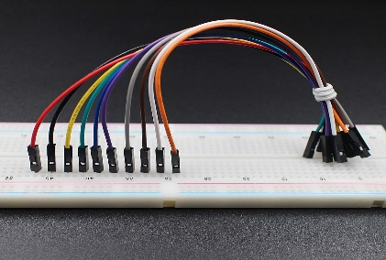

**Figure 8: Jumper wires and Breadboard** (Ada, 2018)

# 2.2.9 Power Supply and Batteries

The 4WD Robot Smart Car Chassis Kit COM37 requires a power supply to drive the motors. In the bus tracking system, a similar setup would require batteries to power the ESP32, GPS, and audio system. Four 3.7V Li-ion batteries can provide the necessary power for a long duration, ensuring that the system remains operational throughout the day. The use of a battery holder simplifies the power management and ensures that the system remains portable and easy to integrate into a real-world bus system (*Electronics Power Supply And Battery Charger Circuit Encyclopedia.Pdf*, n.d.).

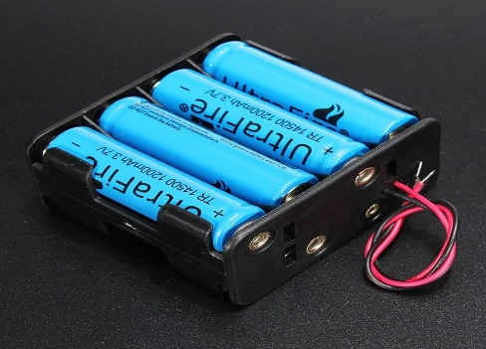

**Figure 9: Battery holder and batteries** (Kumar et al., 2019)

# 2.3 Tools, Techniques, and Languages

Several programming languages and development environments are used to create the bus tracking system:

* **Arduino IDE**: The Arduino IDE is used for writing and uploading code to the ESP32. It provides a simple and effective platform for developing IoT applications, especially for beginners. The ESP32 is supported by the Arduino IDE, making it easy to program using the C/C++ programming languages (Fezari & Al Zaytoona, 2018).

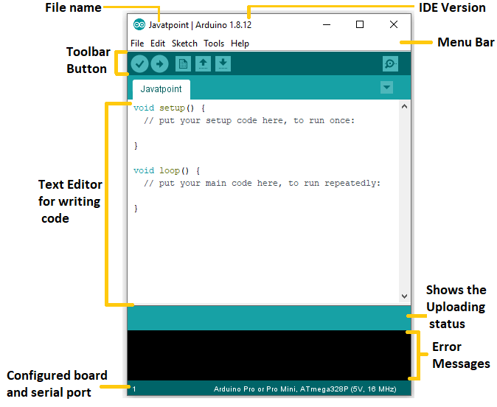

**Figure 10: Arduino IDE** (Fezari & Al Zaytoona, 2018)

* **HTML, CSS, and PHP**: These web technologies are used to create the user interface for the bus tracking system's dashboard. HTML structures the content, CSS styles it, and PHP handles the server-side logic for storing and displaying real-time bus data (Asiva Noor Rachmayani, 2015).

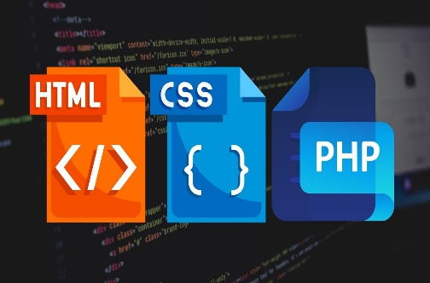

**Figure 11: HTML, CSS, and PHP (Asiva Noor Rachmayani, 2021)**

* **MySQL**: MySQL is used for storing historical data on the bus locations and alerts. It enables efficient querying and retrieval of past data for analytics and monitoring purposes (Asiva Noor Rachmayani, 2015).



**Figure 12: MySQL** (Asiva Noor Rachmayani, 2015)

# 2.4 Review of Related Works

In this section, we explore existing research related to Bluetooth-based location awareness, public transport tracking, and ESP32 microcontroller applications. The review identifies existing solutions, current limitations, and opportunities for innovation in Bluetooth-enabled transport systems.

In another relevant project, B. Khan and M. Rafiq (2021) developed a smart transport assistant system using ESP32 modules to identify stop locations via Bluetooth communication. Their system featured a fixed ESP32 device at bus stops that continuously broadcast signals detected by the ESP32 on the bus. When in range, the system played pre-recorded audio messages to notify passengers. This model showed the feasibility of using Bluetooth-based solutions for public transport, especially in areas with limited GPS coverage (Khan & Rafiq, 2021).

S. Ahmed et al. (2022) studied Bluetooth-based vehicle proximity detection systems and emphasized the reliability of BLE in short-range environments. Their findings confirmed that BLE provides low power consumption and sufficient accuracy for identifying nearby transmitters, making it ideal for fixed-location detection like bus stops or terminals (Ahmed et al., 2022).

Additionally, work by M. Dube and F. Kamana (2023) focused on real-time alert systems in transport environments without GPS. Their approach involved microcontroller-based communication networks using ESP32 for broadcasting signals. Their results highlighted the usefulness of Bluetooth for identifying location context and triggering interactive elements, such as audio alerts or mobile notifications (Dube & Kamana, 2023).

Collectively, these studies support the use of Bluetooth-based communication and ESP32 devices in non-GPS environments for proximity sensing and contextual awareness. While many existing systems still rely heavily on GPS for real-time tracking, there is a growing interest in Bluetooth-powered solutions that offer low-cost, scalable alternatives, particularly for rural or infrastructure-limited settings. This study builds upon these works by implementing a practical system for bus stop detection using ESP32 modules and real-time audio alerts triggered through Bluetooth communication.

Previous research in IoT-based vehicle tracking systems demonstrates the effectiveness of combining GPS, Bluetooth, and other technologies for real-time tracking and passenger alerts. One notable study by X. Zhang et al. (2018) uses GPS and accelerometers to track vehicle location and detect impacts in vehicle accident systems. Similar principles can be applied to bus tracking systems, enhancing location accuracy and reliability. Research by J. Smith and L. Johnson (2019) integrates GSM for communication, providing fast notifications, which could be expanded to integrate Bluetooth communication for proximity-based alerts.

Moreover, studies by P. Kumar et al. (2020) and R. Patel and S. Sharma (2021) highlight the importance of integrating multiple IoT technologies, which can be applied to optimize the bus tracking and alert system.

# 2.5 Identified Gaps in Related Work

Most existing bus tracking systems rely on GPS technology, which can be expensive and requires internet connectivity and constant power. These systems are often not suitable for low-budget or rural transport networks. Additionally, few systems focus on accessibility for people with visual impairments or those unfamiliar with routes. While some projects use mobile apps or digital screens, they may not serve all users effectively. There is a lack of simple, low-cost solutions that provide real-time stop alerts without needing internet or GPS. This project addresses these gaps by using Bluetooth and audio alerts for easy, affordable, and inclusive bus stop notifications.

TABLE

Conclusion

## CHAPTER 3: RESEARCH METHODOLOGY

# ****3.1 Introduction****

This chapter explains the methodology used to design, develop, and evaluate the Bluetooth-based bus tracking and passenger alert system for the Musanze- Kigali public transport road. The main goal of the study is to ensure that the proposed system is practical, reliable, and meets the needs of public transport passengers, especially those with visual impairments or limited road familiarity. The methodology includes the techniques used for data collection and the software development process followed during system creation.

# 3.2 Case Study Overview

The selected case study is the Musanze- Kigali public road, one of Rwanda's most important intercity routes. It connects the capital city with the Northern Province and serves both urban and rural populations. The road was chosen due to its high passenger volume, mixture of travel environments, and the need for improved public transportation communication. This makes it an ideal location for testing a low-cost, Bluetooth-based alert system designed for accessibility and ease of use.

# ****3.3 Data Collection Techniques: Interviews and Questionnaires****

To gain useful insights and feedback, both interviews and questionnaires were used to gather data from key stakeholders. These included public transport passengers, bus drivers, and transport authority representatives operating on the Musanze- Kigali road. Interviews were conducted to gather in-depth qualitative data, especially regarding user needs, challenges with the current system. Questionnaires were distributed to a broader audience to collect quantitative data regarding user satisfaction, accessibility challenges, and opinions on the proposed system features. To ensure the design and implementation of the system are based on actual needs and challenges faced by passengers and bus operators, several data collection techniques were used.

# 3.3.1 Documentation

Existing literature, reports, and system designs on IoT and Bluetooth-based tracking technologies were reviewed. This helped to identify best practices, limitations, and gaps in existing transportation systems.

# 3.3.2 Observation

Direct observation was conducted on the Musanze-Kigali buses. Researchers recorded how passengers interacted with existing systems, how conductors communicated with riders, and noted challenges like missed stops or confusion about locations.

# 3.3.3 Interview

Semi-structured interviews were held with passengers, bus conductors, and transportation authorities to understand their experiences, expectations, and suggestions for improving the travel experience.

# 3.3.4 Sampling Techniques

Purposive sampling was used to select key participants, such as elderly passengers, and individuals with disabilities, to ensure the system supports the needs of a diverse user base.

# 3.3.5 Data Analysis

Data from observations and interviews were analyzed using qualitative methods. Common themes such as lack of stop awareness, difficulty navigating rural stops, and communication gaps were identified and guided the system design.

# 3.4 System Requirements

# 3.4.1 Functional Requirements

* The system should detect when a bus is near a specific stop using Bluetooth.
* The receiver should trigger a pre-recorded audio message to notify passengers.
* Each stop should transmit a unique Bluetooth signal.
* The system must work offline, without GPS or internet.

# 3.4.2 Nonfunctional Requirements

* The system should be low-cost and power-efficient.
* It must be easy to install and maintain.
* Audio messages should be clear and loud enough for passengers.
* Devices should operate reliably in both urban and rural settings.

# 3.5 Hardware Requirements

* ESP32 microcontrollers (transmitter and receiver)
* RDFplayer Mini (for playing audio)
* MicroSD card (storing audio files)
* Speaker module
* Power supply (rechargeable batteries)
* Enclosures for protection during bus operation

# 3.6 System Development Methodology Approach

# 3.6.1 Introduction

The system was developed using a flexible and user-centered software development methodology. This approach allows for iterative improvements based on feedback and testing.

# ****3.6.2 Software Development Methodology****

The Agile methodology was adopted for the development of the system. Agile supports iterative development, allowing for continuous user feedback and gradual improvement of the system based on real-world testing (Trivedi, 2021).

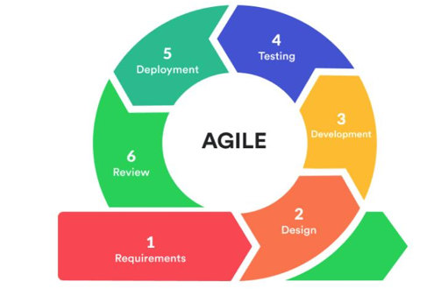

**Figure 13: Agile software development methodology diagram………….**

# ****3.6.3 Requirements Analysis****

During this phase, information gathered from interviews and questionnaires was analyzed to define the system's functional and non-functional requirements. Functional needs included Bluetooth-based proximity detection, audio alert triggering, and system scalability. Non-functional requirements included system reliability, low cost, and user-friendliness.

# ****3.6.3 Planning****

This step involved setting clear timelines, allocating resources, and defining responsibilities for hardware assembly, coding, testing, and deployment. The plan also included milestones for field tests along the Musanze- Kigali road.

# ****3.6.4 Design****

In this stage, the architecture of the system was designed. A modular design was chosen to separate the Bluetooth detection module from the audio alert system. Hardware schematics and flowcharts were created to guide the ESP32 communication between bus and stop, and the triggering of the audio module. Edramax….. …….to design differen UML diagrams……….

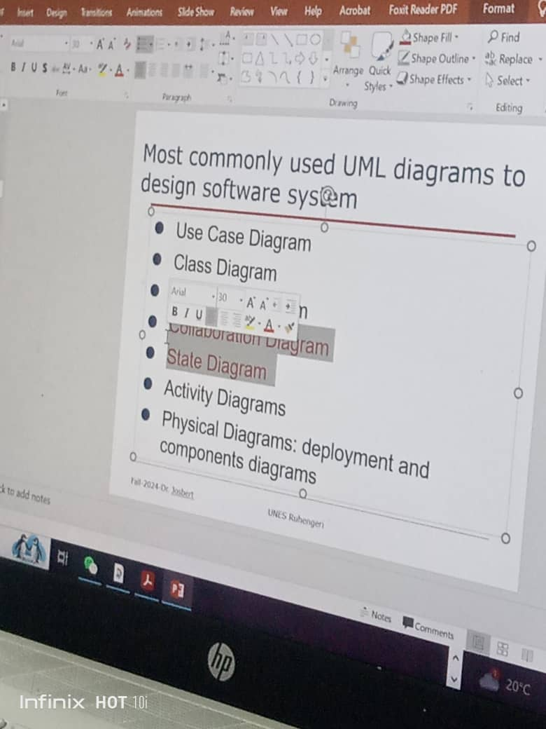

# ****3.6.5 Development****

The development involved coding the ESP32 microcontrollers. One ESP32 was configured as a Bluetooth transmitter to be installed at each bus stop, and the other as a receiver on the bus. The receiver was programmed to detect known Bluetooth signals from the transmitters and trigger the DFPlayer Mini to play an alert message.

# ****;’ 3.6.6 Testing****

The system was tested in real conditions along parts of the Musanze- Kigali road. Tests were conducted to check Bluetooth range, signal detection timing, audio clarity, and response to different environmental conditions. Feedback from passengers and drivers was recorded for improvements.

# ****3.6.7 Deployment****

Following successful testing, the prototype system was deployed in selected bus stops and buses operating between Musanze and Kigali. This phase helped validate the usability and reliability of the system under normal operating conditions.

# ****3.6.8 Review****

After deployment, a review was carried out based on user feedback and performance results. Improvements were suggested, including longer Bluetooth range and multilingual audio messages. These reviews will guide future expansions or improvements of the system.

# ***References***

Ada, Lady. (2018). Breadboards for Beginners. *Adafruit Learning System*, 1–35.

Asiva Noor Rachmayani. (2015). *No 主観的健康感を中心とした在宅高齢者における 健康関連指標に関する共分散構造分析Title*. 6.

Axelsson, C., Åslin, R., & Vestin, A. (2022). *Real-Time Locating System (RTLS) Applicability for ERP Integration PAPER WITHIN: Production systems, specialization in Production Development and Management Guidelines for Applicability and Barriers and Enablers for RTLS and ERP Integration*. *June*.

Bai, L., Ciravegna, F., Bond, R., & Mulvenna, M. (2020). A Low Cost Indoor Positioning System Using Bluetooth Low Energy. *IEEE Access*, *8*, 136858–136871. https://doi.org/10.1109/ACCESS.2020.3012342

Buchanan, M. E. (1981). Methods of data collection. *AORN Journal*, *33*(1). https://doi.org/10.1016/S0001-2092(07)69400-9

Controlled, B., Car, R., Avoiding, O., Car, R., Following, L., & Car, R. (n.d.). *4WD Robot Car Guide*. www.phippselectronics.com

*Electronics Power Supply And Battery Charger Circuit Encyclopedia.pdf* (pp. 1–48). (n.d.).

Espressif Systems. (2021). ESP32 Series. *Esp32*, 1–65. https://www.espressif.com/sites/default/files/documentation/esp32-s2_datasheet_en.pdf

Fezari, M., & Al Zaytoona, A. A. D. (2018). Integrated Development Environment “IDE” For Arduino Integrated Development Environment “IDE” For Arduino Introduction to Arduino IDE. *ResearchGate*, *October*. https://www.researchgate.net/publication/328615543

Handson Technology. (2021a). I2C Serial Interface 1602 LCD Module. *User Guide*, 1–8. https://www.handsontec.com/dataspecs/module/I2C_1602_LCD.pdf

Handson Technology. (2021b). Motor Driver L298N. *Handson Technology*, 1–7. www.handsontec.com

Jordi Salaza, & Silvestre, S. (2017). Tech Pedia Internet Of Things. In *Cyber Resilience of Systems and Networks* (Vol. 14, Issue July 2016). http://link.springer.com/10.1007/978-3-319-77492-3_16

Kumar, S., Tiwari, P., & Zymbler, M. (2019). Internet of Things is a revolutionary approach for future technology enhancement: a review. *Journal of Big Data*, *6*(1). https://doi.org/10.1186/s40537-019-0268-2

Mohamed, K. S. (2022). An Introduction to Bluetooth. *Bluetooth 5.0 Modem Design for IoT Devices*, 1–32. https://doi.org/10.1007/978-3-030-88626-4_1

PICAKE. (2020). 2 . Module Application Instruction. *Module Application Instruction*, 1–12.

Simister, N., & James, D. (2020). Quantitative and Research. *Statistics*, 1–6. https://www.intrac.org/wpcms/wp-content/uploads/2017/01/Quantitative-and-qualitative-methods.pdf

Trivedi, D. (2021). *Agile Methodologies*. *December*.